This chapter explains how, when and where to use distributions we have learned so far.

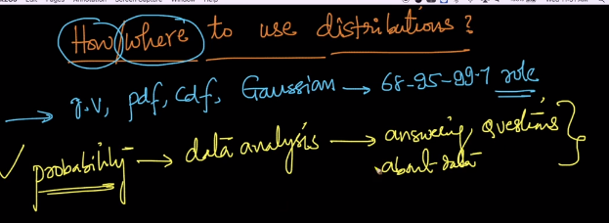

These all techniques are used for data analysis which gives all the required answers about the data.

Let’s take examples:

1. **Finding no of candidates for different size of t-shirts(s, m, l, xl).**

You are working In a company with employess (100k), now you’ve to order t-shirts for all the employees.

But the problem is to know the counts of each size of t-shirt we’ve to order.

Like how many XL t-shirts should I order.

To answer this, we can do following steps:

* Collect data for small sample of employees let’s say 500 employess.
* And get domain knowledge as:
  + If height >= 180 cm then XL size is there
  + If 160 <= height < 180 cm then L size is there
* Find mean and variance of sample.
* If we know that given sample or all employees height follows guassian distribution then we can draw PDF and CDF which can tells us how many %age of employees need XL size.

Ofcourse we  can plot CDF as well as PDF for any kind of distribution, but the only thing is that in normal distribution we have those nice rules such as 68-95-99% with which you can easily get the required stats and information whereas other distributions we have to look at those plots and form our suitable rules. So it's easy for us to analyse the situation when the data is normally distributed.

**Note**: QQ plot can be used to check whether employees height follows gaussian distribution or not.

* If we came to know that sample is normal distributed then we can use all the techniques we used like PDF, CDF, 65-97-99 rule, to perform data analysis.

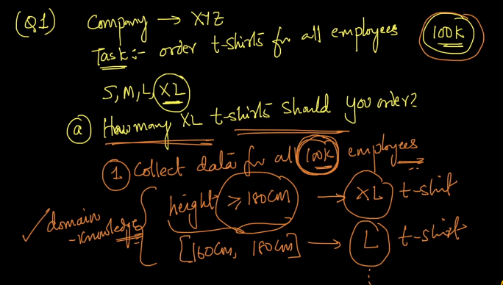

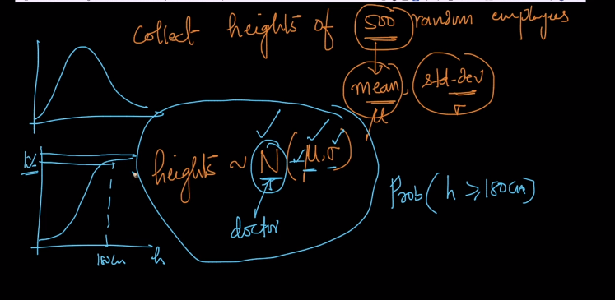

1. **For a company finding the with large no of employees finding how many employees make salary greater than 100k $.**

Like above example, here also we take a sample and if the employees salary are normally distributed then we can calculate median and variance, through which we can draw CDF which will let us know the probability or percentage of employee make salary greater than 100k $.

